Dear Parents,

We hope you have enjoyed your Easter Break and you are all safe and well. We have decided to use a website called Study Ladder to help encourage children with their home learning this week. Based on your feedback we will be able to decide if this resource is more useful with home learning. Please email us with your comments/questions. Each child has their own login details.

To make logging in easier you just look for your child’s name and enter their unique password which we will email to your child’s school email address. If you are unable to log into your child’s school email address, please contact us so we can resolve this issue for you.

Miss Cheema’s Class:
https://www.studyladder.co.uk/myschool/39210/myclass/1213763

Miss Cartwright’s Class:
https://www.studyladder.co.uk/myschool/39210/myclass/1213766

When your child logs in a popup will appear: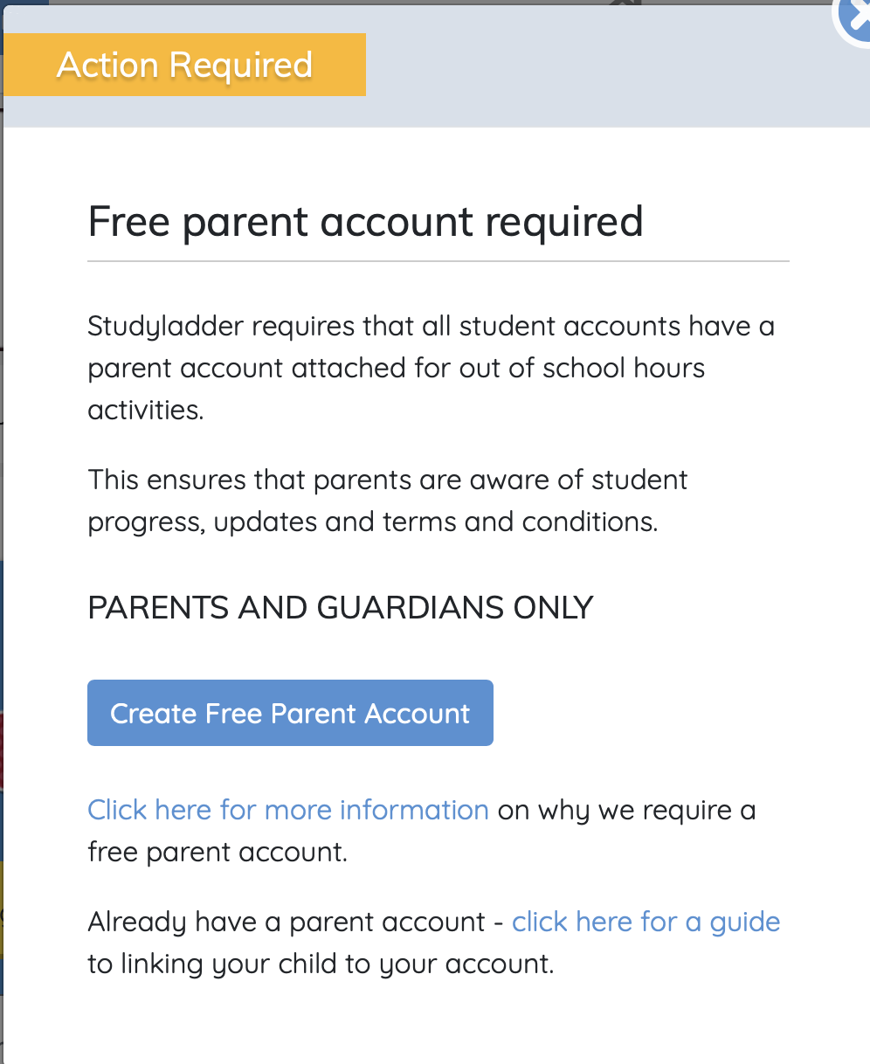

Please ignore this popup as it only applies if your child will be using the website out of school hours.
We will be able to track the progress your child is making within all the tasks we have set. Please ensure your child has the opportunity to complete this work. These are the tasks we have set on Study Ladder this week:

Maths focus – Addition

English focus – Initial sounds

Understanding the World – Earth and Space

Health and Wellbeing – Sun safety

Expressive Arts and Design – Paint and draw

Additional resources and ideas for home learning:

Maths: odd and even

Please continue practising halving and identifying odd and even numbers. Your child should be familiar with this concept however, some many require more practise. Please see odd and even worksheet which is available to print.

English: Supertato

This week’s story will be Supertato! We have read this story before, but your child might need reminding! There is a link YouTube to the story being read:
https://www.youtube.com/watch?v=M1nlJBkWGLo

Some tasks to complete with your children based on the story:
- Writing sentences about what happened in the story. This needs to be 100% independent rather than them copying spellings.

- Design their own character to add into the story

- Play a game asking your child to find words being with a certain letter. This will help improve their phonics knowledge.

Physical activity:

Here are a range of physical activity videos that you can watch and join in with on YouTube.

https://www.youtube.com/watch?v=KhfkYzUwYFk
https://www.youtube.com/watch?v=LhYtcadR9nw
https://www.youtube.com/watch?v=NwT5oX_mqS0
https://www.youtube.com/watch?v=2UcZWXvgMZE
https://www.youtube.com/watch?v=SH-7A3NVQbY

Please upload as much as possible to Tapestry, if you cannot log on please email as we can reset your passwords for you.

Please email any questions/queries to:
kiren.cheema@rydersgreen.sandwell.sch.uk
leah.cartwright@rydersgreen.sandwell.sch.uk
lesley.banner@rydersgreen.sandwell.sch.uk
izabella.jasinska@rydersgreen.sandwell.sch.uk

