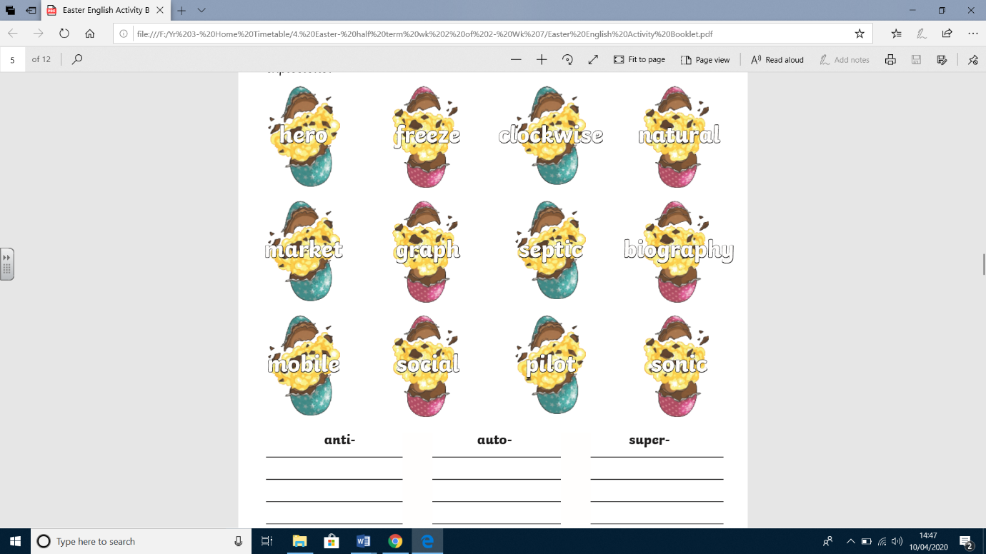Eggs have been exploding in the factory because a recipe has been muddled up. Match the root word to the correct prefix to stop the explosion.

Now, using the words write Easter themed sentences.