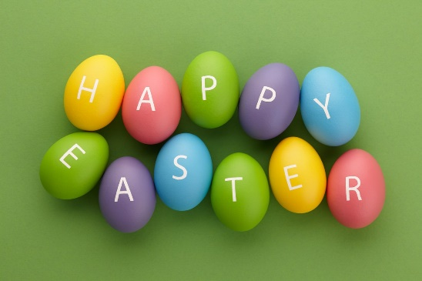**Week commencing 13.4.20**

**Easter Holiday ‘Pick and Mix’**

Hello everybody. I hope you are safe and well.

I hope you enjoyed the Easter activities that we gave you to do last week in preparation for the Easter Bunny.

Please remember that we still have paper work packs in school that can be collected from the main office and that all children have an e-mail account to contact us on with your assistance of course!

If you don’t know your child’s e-mail address, please contact the school number and we will be able to provide you with this.

Please choose two activities each day from the grid below.

|  |  |  |  |  |
| --- | --- | --- | --- | --- |
| Look at a cloud and say what it looks like. | Put water on rocks with a paintbrush and see what happens to the colours. | Make binoculars out of toilet paper rolls. Decorate them and look through them. What can you see? | Find a jigsaw puzzle and see if you can complete it by yourself. | Master a new skill such as putting on your coat and zipping it up, putting gloves on correctly or putting on your shoes all by yourself! |
| Look out of your window or go in your garden what can you see? Take a photo of them and talk about them. | Choose some music to listen to and make up your own dance. | Memory Game  Collect ten small objects from  around the house and put them on  a tray. Ask the other person to look  away while you take away one  object. When they open their eyes,  they guess what is missing. | Choose something that you like to eat or drink and help your grown up to make it for you. | Keep reading! Read anything that you can. Books, magazines, leaflets, catalogues, food packets, instructions, recipes. |