Year 6 weekly timetable - Monday 13th April 2020
Time | Monday 13th April | Tuesday 14th April | Wednesday 15th April | Thursday 16th April | Friday 17th April
Before 9am | Morning routine | Morning routine | Morning routine | Morning routine | Morning routine
9am | Joe Wicks workout  https://www.youtube.com/watch?v=d3LPrhI0v-w | Joe Wicks workout  https://www.youtube.com/watch?v=EXt2jLRlaf8 | Joe Wicks workout  https://www.youtube.com/watch?v=5MBEyQIlrfo | Joe Wicks workout  https://www.youtube.com/watch?v=d3LPrhI0v-w | Joe Wicks workout  https://www.youtube.com/watch?v=EXt2jLRlaf8
9.30am | English  Film Review  Write a review of the last film you watched. Do not spend more than one quarter of the essay retelling the plot: your review should focus on your opinion about the film. | English  Advertise your town  Persuade your reader to take their next holiday to the place where you live. Think of 5 positive reasons as to why someone should visit your town, ensure to explain each point thoroughly and use persuasive language and a range of punctuation! | English  Classroom Conundrum  The word conundrum means a confusing or difficult problem or question. Write a short story with the title ‘Classroom Conundrum’, what ideas can you come up with, ensuring to use a wide range of vocabulary and punctuation to make it exciting. | English  The Titanic  If you are unsure about the Titanic, do a little bit of research or ask a grown up what they know about it.  Now write a diary entry as though you are a member of the crew on board the Titanic after it struck the iceberg. | English  Ancient Myths  Write your very own myth set in an ancient civilisation of your choice, it could be somewhere that you have learnt about during your time in school, i.e. Ancient Egypt or Ancient Greece, or maybe somewhere you have completely made up, use plenty of descriptive language to fully immerse your reader.
10.15am | Break – get some fresh air | Break – get some fresh air | Break – get some fresh air | Break – get some fresh air | Break – get some fresh air
10.30am | Bug Club | Bug Club | Bug Club | Bug Club | Bug Club
10.45am  11.45am | Maths  Maths activity booklet  Complete 2 pages let your teacher know how you got on  The booklet will be emailed to you, if you can access a printer you can print it off and complete it that way, if not notes in your books are just fine! | Maths  Maths activity booklet  Complete 2 pages let your teacher know how you got on | Maths  Maths activity booklet  Complete 2 pages let your teacher know how you got on | Maths  Maths activity booklet  Complete 2 pages let your teacher know how you got on | Maths  Maths activity booklet  Complete 2 pages let your teacher know how you got on
11.45-12pm | ERIC | ERIC | ERIC | ERIC | ERIC
12pm-12.30pm | SPaG  Century Tech | SPaG  Century Tech | SPaG  Century Tech | SPaG  Century Tech | SPaG  Century Tech
1.30pm-2.30pm | The Mystery of the Missing Knight  St GEORGE’S Day Maths mystery game  Can you solve it?  This will be emailed to you. | History  Research task  Take a look at the current situation with the supermarkets and make comparisons between that and how the rationing system worked during WW2 – what are the similarities and differences? How could a rationing system help our situation now? How would the rationing system be difficult for us today?  Email your class teacher your responses | Geography  https://www.bbc.co.uk/bitesize/topics/zshp34j/articles/z6m7vk7  watch the videos and read the information on sustainability and plastics – take the quiz to test your knowledge  take a look around the house and see what you can find that could be recyclable – make a list of everything that you find. | Art  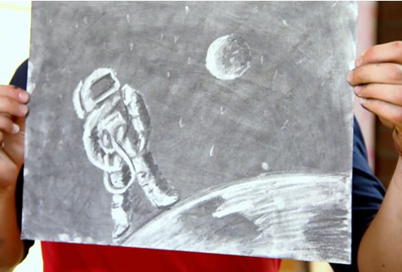  https://www.bbc.co.uk/bitesize/clips/zpnm4j6  have a go at your own art stencil work using an eraser. You should have the resources from your home pack. Email an image to your class teacher if you can. | Get outside  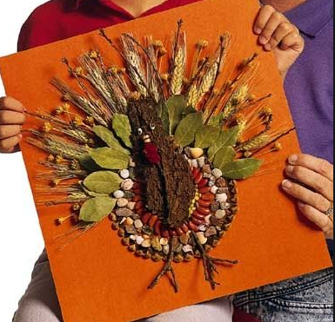  Get out into the garden – collect leaves, twigs, stones and any other natural sources you can find and create your own spring picture. This can be done outside on the garden floor or stuck onto paper. Get creative and enjoy!
2.30pm-3pm | Creative activity –  http://www.robbiddulph.com/draw-with-rob | Creative activity –  http://www.robbiddulph.com/draw-with-rob | Creative activity –  http://www.robbiddulph.com/draw-with-rob | Creative activity –  http://www.robbiddulph.com/draw-with-rob | Creative activity –  http://www.robbiddulph.com/draw-with-rob
3p;m-3.15pm | Newsround  https://www.bbc.co.uk/newsround/news/watch_newsround  Send an email to your class teacher with your opinion of the news of the day. | Newsround  https://www.bbc.co.uk/newsround/news/watch_newsround  Send an email to your class teacher with your opinion of the news of the day. | Newsround  https://www.bbc.co.uk/newsround/news/watch_newsround  Send an email to your class teacher with your opinion of the news of the day. | Newsround  https://www.bbc.co.uk/newsround/news/watch_newsround  Send an email to your class teacher with your opinion of the news of the day. | Newsround  https://www.bbc.co.uk/newsround/news/watch_newsround  Send an email to your class teacher with your opinion of the news of the day.
3.15pm | End of school day – don’t forget that you should still read your home reader to your parents/ carers | End of school day – don’t forget that you should still read your home reader to your parents/ carers | End of school day – don’t forget that you should still read your home reader to your parents/ carers | End of school day – don’t forget that you should still read your home reader to your parents/ carers | End of school day – don’t forget that you should still read your home reader to your parents/ carers

Your year group teachers will be available to reply to emails between 9am and 3.30pm Monday – Friday. During this time, they will be working on other school priorities as well, so you may not get an emailed reply straight away. Any emails after 3.30pm will be replied to the following morning and if emails are received over the weekend you will receive a reply on Monday morning.

Miss Adams rebecca.adams@rydersgreen.sandwell.sch.uk  Miss Allen rebecca.allen@rydersgreen.sandwell.sch.uk | Miss Randle samantha.randle@rydersgreen.sandwell.sch.uk  Miss Garrington faye.garrington@rydersgreen.sandwell.sch.uk  Any technical support you may require or if you are having any problems with your logins please contact:  Miss Johal angela.johal@rydersgreen.sandwell.sch.uk

