Dear Parents,

We hope you have had another successful week of home learning. If you have any concerns at, please feel free to contact us and we will support you the best we can. We will be continuing to use Study Ladder. We have looked at Study Ladder and have decided to allow another week for your child to complete the outstanding tasks.

Study Ladder links:

Miss Cheema’s Class:

<https://www.studyladder.co.uk/myschool/39210/myclass/1213763>

Miss Cartwright’s Class:

<https://www.studyladder.co.uk/myschool/39210/myclass/1213766>

The study ladder topics:

Maths – Patterns and Data

English – CVC words

Understanding the world – Physics – Materials

Phonics:

The scheme of phonics we follow at school is Read Write Inc. They are currently uploading a new video each day with a sound. The video is available for 24 hours therefore it is important that your child watches the video and follows the instructions each day as once they have been removed you cannot revisit them.

Please follow the link below and click on the first video under ‘Set 1 Lessons’

<https://www.youtube.com/channel/UCo7fbLgY2oA_cFCIg9GdxtQ>

The video will change each day, but you always click the first video. Once the video has finished click back and then click the video ‘ Set 1 Word Reading’. Once finished click back and then click the final video which will be ‘Set 1 Spelling’ Your child will need to have some paper and a pencil to write with for the last video. Your child should be able to concentre on the videos as this is our usual phonics routine.

If you are struggling with home learning please try to focus on the phonics aspect of your child’s learning as it is fundamental to most areas of the curriculum.

Reading:

We have noticed that a lot of children have logged onto their bug club please can you ensure that you have the log in details and allow your child to access this site once a day. Each child has their own login details for bug club. They have been set books that they can read independently or with support. We are able to keep a log of which books your child has read. This is a fantastic resource to help with your child’s reading. If you need your login details sent, please get in touch via your **child’s** school email account.

Technology:

The following link is to a website which is similar to paint it is very user-friendly, and your child should be able to use it independently.

<https://www.j2e.com/jit5#paint>

Physical Education:

Please pick a video from the link below, based on your child’s interests. <https://www.youtube.com/watch?v=ybn_SO990go>

History:

If we were at school this week we would all be taking part in History week. The topic planned for Reception is The Olympics. There are fun activities that you can do this week to learn about The Olympics. The activities are as follows:

* Monday-Research the history of The Olympics. Where did the Olympics come from? How and when did they start? Who were some of the first Olympic champions? Where were the games first held? What did the stadiums look like? How are they different from our stadiums today?

Ask your child to design their own medal that they would give out at The Olympics.

* Tuesday- talk about the differences between The Olympics in the past and now. What has stayed the same? What is new? Why have things changed?
* Wednesday- recreate your own Olympic games- you could choose to do this outdoors with your siblings. You could set up running races, throwing a ball as a shotput, find a stick and use it as a javelin. You might want to make your own rewards or medals for the winners.
* Thursday- draw a picture of your favourite athlete. Talk about what you like about them and why.
* Friday- draw an Olympic stadium. You can look online for ideas or if you're feeling creative you could create your own Olympic stadium model.

Please send any pictures of your work or your own Olympic games to us through email or upload onto tapestry as we would love to see them

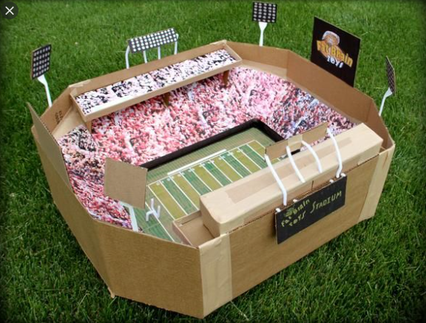

We have also uploaded some additional worksheets if you are struggling to access study ladder, or if your child completes their work on study ladder. Please keep in touch via email or tapestry.

Thank you for your on-going support,

Miss Cheema and Miss Cartwright

[Kiren.cheema@rydersgreen.sandwell.sch.uk](mailto:Kiren.cheema@rydersgreen.sandwell.sch.uk)

[Leah.cartwright@rydersgeen.sandwell.sch.uk](mailto:Leah.cartwright@rydersgeen.sandwell.sch.uk)