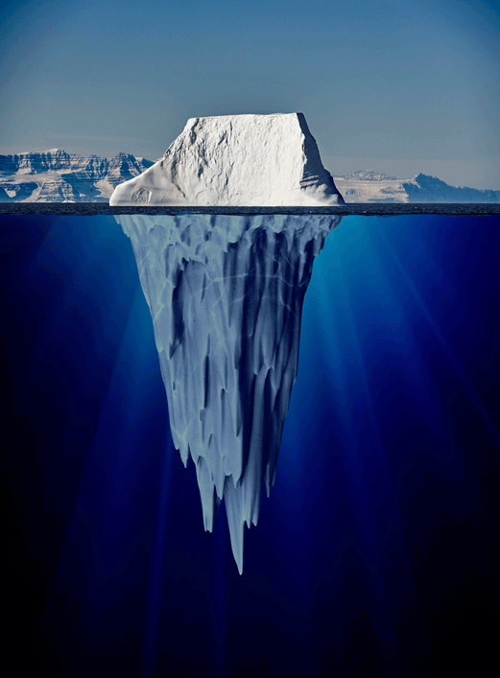

**Icebergs - English booklet**

**Learning objectives:**

To select the appropriate form for audience and purpose.

To note and develop initial ideas for writing.

To select appropriate grammar and vocabulary.

To always proof read for errors and effectiveness.

To use expanded noun phrases.

**Geography learning objective:**

To locate the world’s continents and countries.

**Monday**

Turn back the clock to 14th April 1912. The day that the Titanic found out the true power of these ice giants!

**Activity:**

Watch these clips and start your research on the Titanic. On the second clip, give some thought to how the passengers on the lifeboats were feeling as they watched the Titanic sink in front of them?

<https://youtu.be/4pywFRpEcZA>

<https://www.youtube.com/watch?v=fHJ8DwXlFyQ>

<https://www.bbc.co.uk/bitesize/clips/zc78q6f>

**Key questions:**

1. Why was the Titanic build?
2. What happened to the Titanic? – Your teachers expect a more comprehensive answer than “It sank.”
3. Why were women and children chosen to go on the lifeboats first?
4. Could the disaster have been avoided?
5. What measures were put in place after the sinking to make sure that this kind of disaster never happens again?

Email your work to your teacher.

**Tuesday**

**Activity:**

Imagine that you are watching the sinking of the Titanic from the safety of one of the lifeboats. Take a minute to really think about how this would feel and what you would see and hear.

Writing **in sentences** - using as much descriptive language by adding in powerful adjectives.

What do you see?

What do you hear?

What do you smell?

What can you taste in the air?

How are you feeling?   
Add show not tell here to describe your feelings. For example “The hairs on the back of my neck rose up and my whole body started to tremble. Tears starts to fall from my eyes.”

Email your work to your teacher.

**Wednesday & Thursday**

**Activity:**

1. Practicing fronted adverbials: Complete the worksheets provided.

Bronze- 1a-3b

Silver – 4a – 6b

Gold – 7a – 9b

1. Write an account of the event as if you were one of the saved passengers of the Titanic. You have already written some sentences that you can use in this writing.

Use the five points below to structure your work and write **at least** one paragraph for each point.

Each paragraph should start with a fronted adverbial to make your writing more interesting.

Edit and up level your work as you would do in class.

* Begin by seeing the scene through the character's eyes (e.g. I looked at the catastrophe before me.)
* Describe what you can see.
* Then, describe what you could hear.
* Add in a taste or a smell.
* Finally, finish with a final reflection on how the character feels.

**Here is a short model go help you…**

*Clambering into the lifeboat, I looked back at the chaos behind me. The Titanic slumped into the sea, wounded from battle. Victorious, the vast ice giant stood triumphant, unmoved. As the lights plunged into darkness, all that was left were the helpless screams of those left behind, their fate sealed. A bitter taste suddenly rose up and stung my throat as uncontrollable tremors surged through my body, paralysing me. It was over.*

Email your work to your teacher.

**Friday**

What do you know about icebergs?

<https://www.bbc.co.uk/bitesize/topics/zkgg87h/articles/z9ck9qt>

<https://www.bbc.co.uk/bitesize/guides/zd4j6sg/revision/1>

**Activity:**

1. Develop your own vocabulary list – these are the words that you have found that describe icebergs, their location, or the process of them forming, or are words that you have had to look up the definition of. Your list should have at least 10 words.
2. Write a fact file about icebergs. You can present it in any way you wish- a poster, a power point presentation or a booklet.

You need to answer the following questions in your fact file:

* How are icebergs formed?
* How old is an iceberg?
* Where are icebergs found and why? (Continents/oceans)
* Where are icebergs not found and why? (Continents/oceans)
* What percentage of an iceberg is above and below the water? Why does this happen?
* Why was a large ship like the Titanic damaged so badly by a block of ice? (What are the properties of the ice that made it capable of causing so much damage if hit? Think of the way the hull of a ship is built).

Email your work to your teacher.