Year 2 weekly timetable – Week commencing Monday 13th July 2020
Time | Monday | Tuesday | Wednesday | Thursday | Friday
Before 9am | Morning routine  Get ready for your day! | Morning routine  Get ready for your day! | Morning routine  Get ready for your day! | Morning routine  Get ready for your day! | Morning routine  Get ready for your day!
9am | Joe Wicks workout  https://www.youtube.com/watch?v=d3LPrhI0v-w | Joe Wicks workout  https://www.youtube.com/watch?v=EXt2jLRlaf8 | Cosmic Yoga- star wars  https://www.youtube.com/watch?v=coC0eUSm-pc | Joe Wicks workout  https://www.youtube.com/watch?v=d3LPrhI0v-w | Cosmic Yoga- Fernando the Fox  https://www.youtube.com/watch?v=XU1y7pX7dNo
9.20am | Maths  https://whiterosemaths.com/homelearning/year-2/  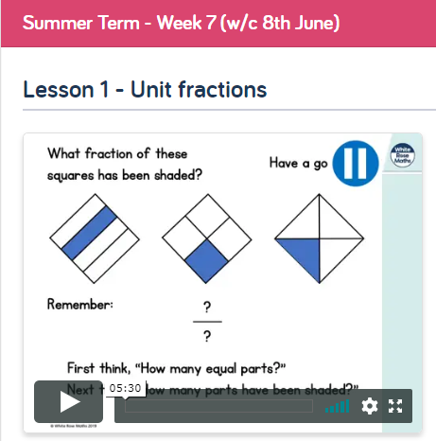 | TT Rockstars  Use your login details.    https://whiterosemaths.com/homelearning/year-2/  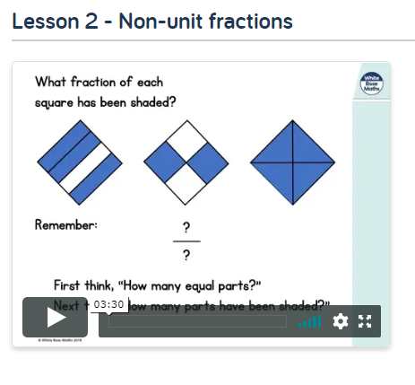 | Maths  Practise forming your numbers. 0-9  1 page of your Maths booklet. Problem of the day-day 6.  https://whiterosemaths.com/homelearning/year-2/  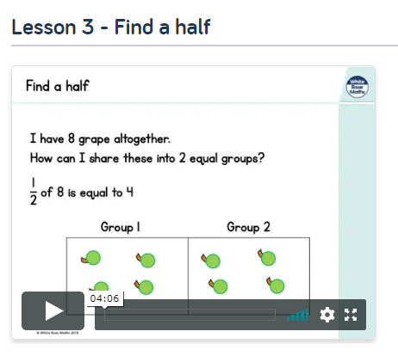 | TT Rockstars  Use your login details.  https://whiterosemaths.com/homelearning/year-2/  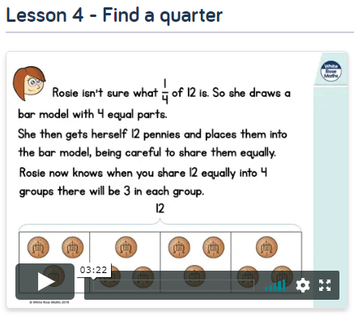 | Maths  https://www.bbc.co.uk/bitesize/articles/zqpvhcw  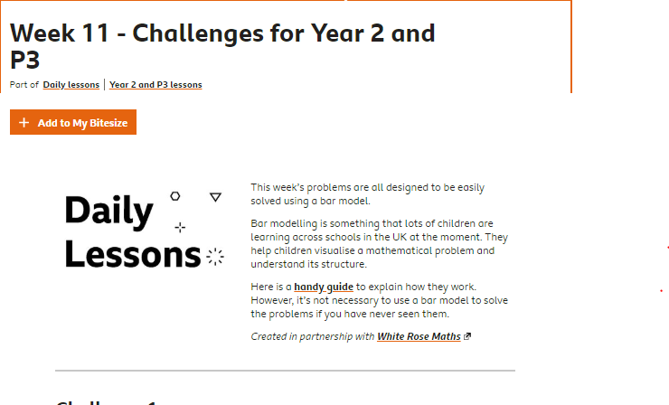
10am | Break – get some fresh air | Break – get some fresh air | Break – get some fresh air | Break – get some fresh air | Break – get some fresh air
10.20am | Bug Club | Bug Club | Bug Club | Bug Club | Bug Club
10.50am | English  Practise your letter formation  x  This is your final week in year 2. So it’s time to show off all you have learnt. Write a diary entry describing one of the days in lockdown. How have you felt? What have you been up to? What do you miss? What are you excited to do once things become a little more normal? | English  Practise your letter formation  y  https://www.literacyshed.com/thewaybackhome.html  Watch the story. You will be rewriting it. Create a short plan of what happens in the story. Challenge: can you change parts of the story? | English  Practise your letter formation  z  Use your plan from yesterday’s lesson to write your story.  Think carefully about  -your handwriting  - challenging vocabulary  -conjunctions  -punctuation  -questions  -speech | English  Practise your letter formation  Write your name, with all the letters correctly written.  Complete your story today and read aloud in an interesting way to someone at home. How could you improve it?  If you want to, take a picture and send it to us to read! | English  Practise your letter formation  Write your favourite season, with all the correct letters.  Today would have been your last day in year 2. Write a short memory of something you enjoyed doing in year 2.  You could even write a letter to one of your friends or teachers!  Thank you all for all of your hard work. You are all superstars.
11.30am | Lunch | Lunch | Lunch | Lunch | Lunch
12.30pm | Read your school book or a book of your choice.  https://www.oxfordowl.co.uk/for-home/reading/ | Read your school book or a book of your choice.  https://www.oxfordowl.co.uk/for-home/reading/ | Read your school book or a book of your choice.  https://www.oxfordowl.co.uk/for-home/reading/ | Read your school book or a book of your choice.  https://www.oxfordowl.co.uk/for-home/reading/ | Read your school book or a book of your choice.  https://www.oxfordowl.co.uk/for-home/reading/
12.50pm | Walking on sunshine  https://www.youtube.com/watch?v=41SkJVsm7Os | Uptown Funk  https://www.youtube.com/watch?v=cntzSx-KdWw | Old town Road  https://www.youtube.com/watch?v=dx6wHN0VsJo | Watch me whip, watch me nae nae  https://www.youtube.com/watch?v=bMZAuhadz2Y | Macarena  https://www.youtube.com/watch?v=EXt2jLRlaf8
1.20pm | Creative activity – Draw with Rob    https://www.youtube.com/watch?v=ZWeCKiU-qUs | Create your own rocket  This could be a drawing or even a 3D one. Where will your rocket go? | Creative activity –Draw with Rob  https://www.youtube.com/watch?v=J2dbjML24ok | PE  https://www.youtube.com/watch?v=3m5DlVnxLjk | Creative activity – Draw yourself as a super hero.  https://www.youtube.com/watch?v=_OZxBGzyu74 (super man)  https://www.youtube.com/watch?v=66-JbNbmNdQ  (supergirl)  Remember we want the character to be you, so draw your face!  We want you to do this because we think you are all super heroes. This year has been very different but you have worked so hard and shown us how wonderful you really are. Well done !  
2. 45pm | Reading slot  Class reader / Bug Club | Reading slot  Class reader / Bug Club | Reading slot  Class reader / Bug Club | Reading slot  Class reader / Bug Club | Reading slot  Class reader / Bug Club
3.15pm

Your year group teachers will be available to reply to emails between 9am and 3pm Monday – Friday. During this time, they will be working on other school priorities as well, so you may not get an email reply straight away.

Mrs Trapani luisa.trapani@rydersgreen.sandwell.sch.uk  Miss Kaur sanjeet.kaur@rydersgreen.sandwell.sch.uk  Miss Ebanks kelly.ebanks@rydersgreen.sandwell.sch.uk | Mrs Robinson lisa.robinson@rydersgreen.sandwell.sch.uk  Mrs Leech gwen.leech@ydersgreen.sandwell.sch.uk

