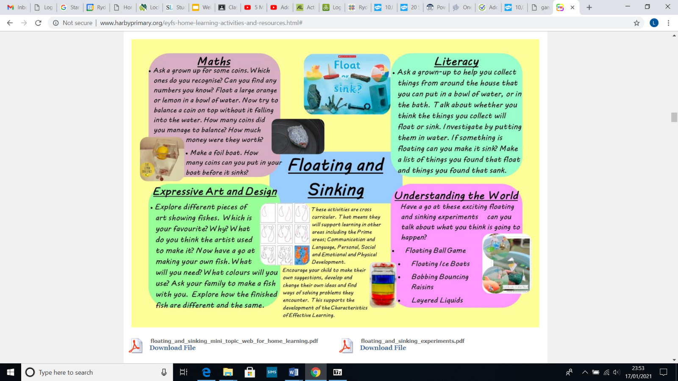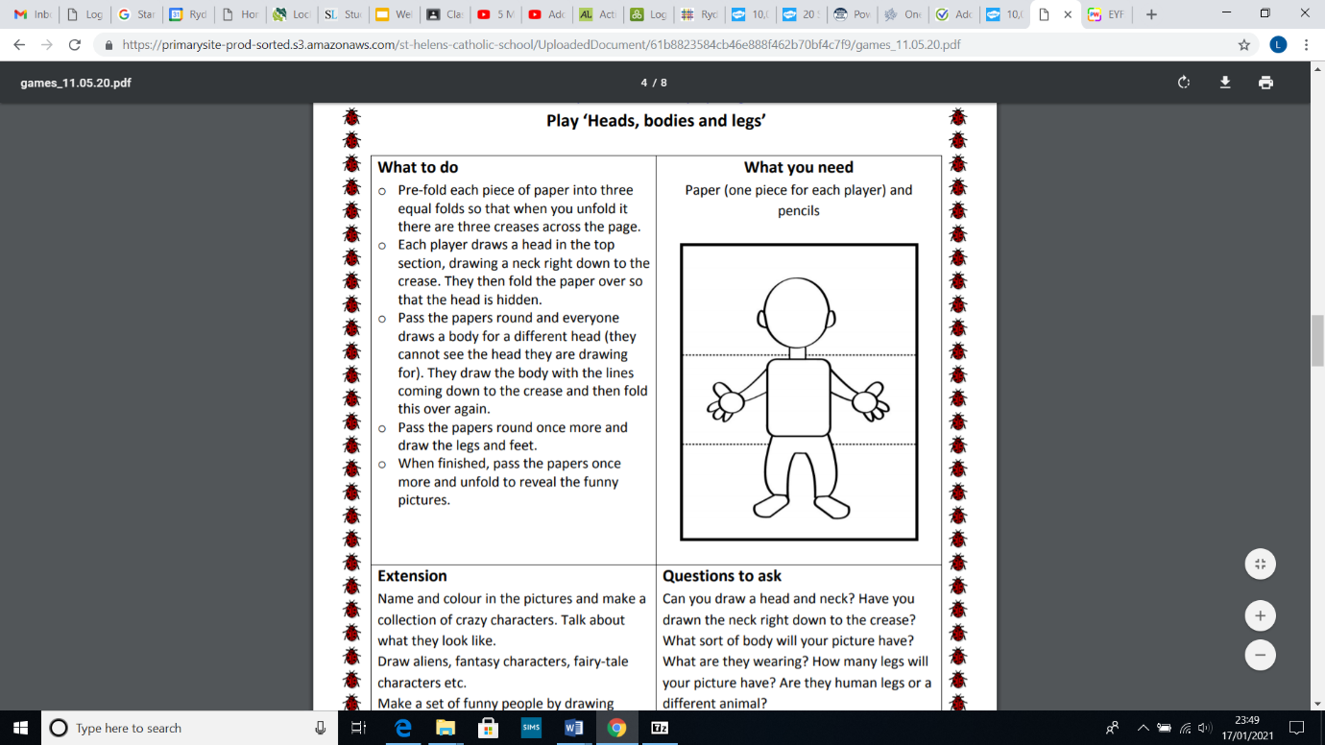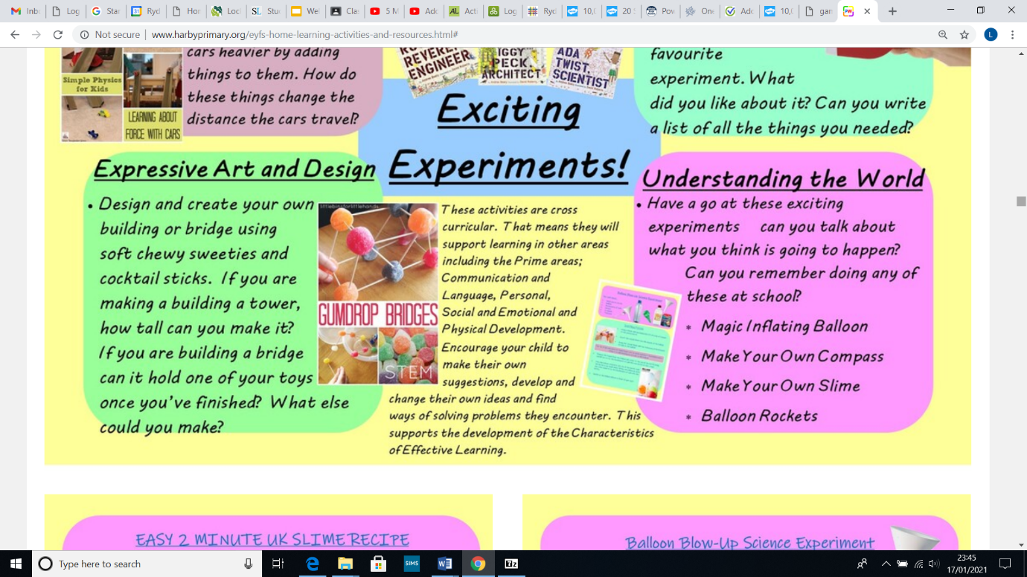Home Learning Challenges

Ask a grown up to help you collect things from your home that you can put in a bowl of water. Talk about whether you think they will float or sink. Investigate by putting them in the water.

Play Heads, bodies and legs

Pre-fold each piece of paper into three equal folds so that when you unfold it there are three creases across the page.

Each player draws a head in the top section, drawing a neck right down to the crease. They then fold the paper over so that the head is hidden.

Pass the papers round and everyone draws a body for a different head (they cannot see the head they are drawing for). They draw the body with the lines coming down to the crease and then fold this over again.

Pass the papers round once more and draw the legs and feet.

When finished, pass the papers once more and unfold to reveal the funny pictures.

Design and create your own building bridge using soft chewy sweet and cocktail sticks. If you are making a tower, how tall can you make it? If you are building a bridge, can it hold one of your toys once you have finished? What else could you make?